Using SMART Sync Teacher
Starting SMART Sync
- Double-click the SMART Sync Teacher 2010 icon on your desktop.
The SMART Sync window and Welcome to SMART Sync dialog box appear.
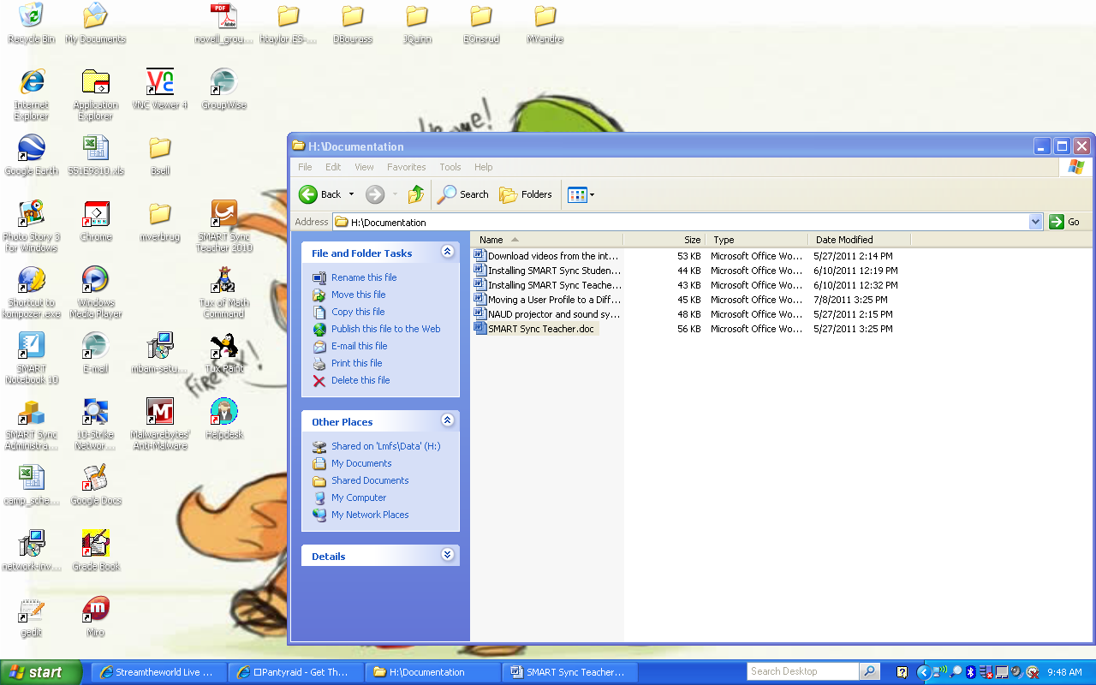
- Select your teacher ID in the Teacher box.
- Select your class in the Class box.
- Click OK.
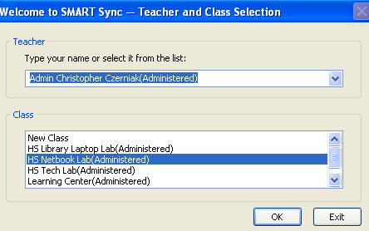
Observing Student’s Desktops
You can view a student’s desktop and switch between the live image of your student’s desktop and the other parts of SMART Sync, such as the Chat, Quiz, and File transfer views.
To view a student’s desktop:
- Click Thumbnails.
- Double-click the student’s thumbnail.
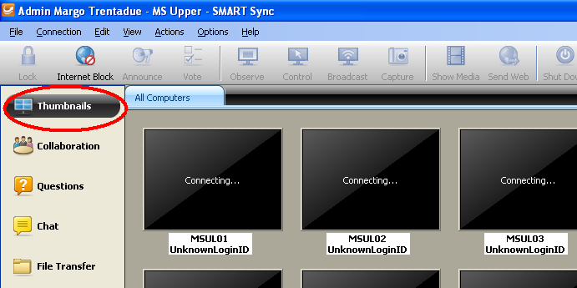
The student’s desktop appears in Window mode.
- Click Stop to stop viewing the student’s desktop.
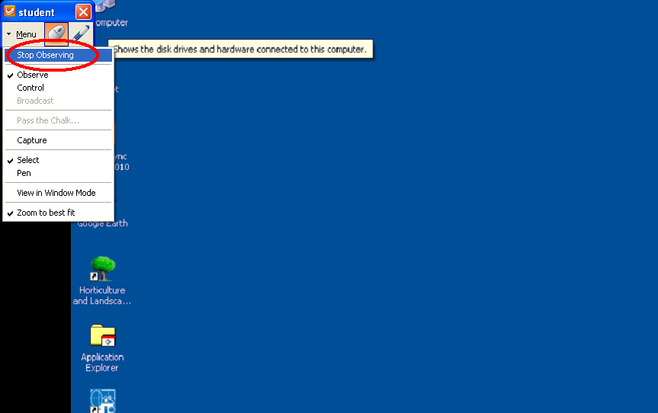
Controlling a Student’s Desktop
When you’re observing a student, you can take sole control or share control of the student’s desktop. Any changes you make when you take sole control of the student’s desktop are visible to the student in real time.
To control a student’s desktop:
- Click Thumbnails.
The Thumbnails view appears.
- Select the student’s thumbnail, and then click Menu>Control.
The student’s desktop appears in Window mode.
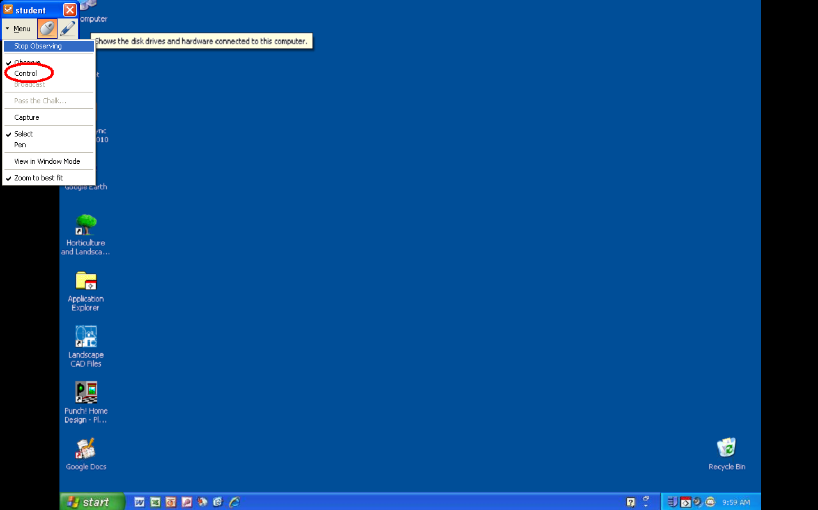
- Click Menu>Stop Controlling to stop controlling the student’s desktop.
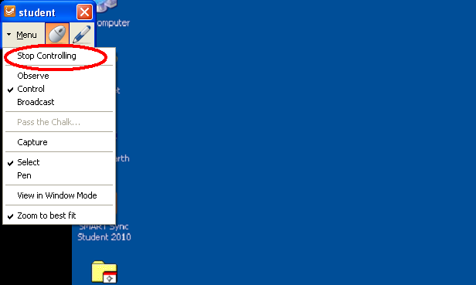
Drawing on a Student’s Machine
When you’re observing a student, you have the ability to draw on the student’s desktop. Any markings you make on the student’s desktop are visible to the student in real time.
To draw on a student’s desktop:
- Click Thumbnails.
The Thumbnails view appears.
- Select the student’s computer you wish to observe.
The student’s computer will appear in Window mode.
- Select the Pen icon in the top left, and begin making the markings you desire.
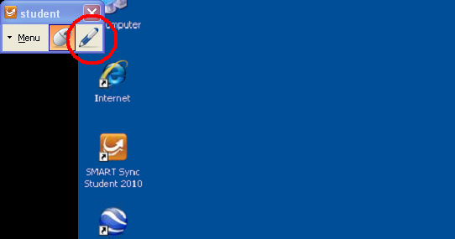
- Click Menu>Stop Observing to stop drawing.
This will also take you out of Window mode.
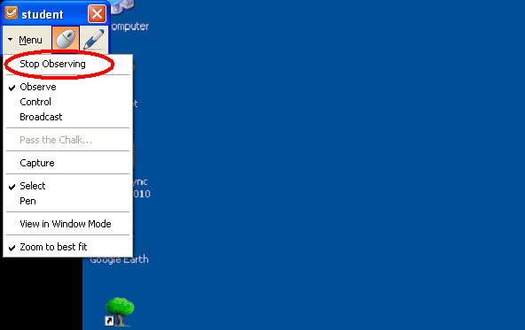
Locking Student Desktop
You can get the attention of your class, a group or an individual student by temporarily locking their mouse devices, keyboards and desktops and presenting them with a simple message.
When you lock students’ computers, you don’t delete any of their work. When you remove the lock, the students’ desktop views and control are completely restored.
To lock student desktops:
- Click Thumbnails.
The Thumbnails view appears.
- Click All Computers or All Students to lock all students’ desktops
OR
Select a student’s thumbnail to lock only the desktop of that student.
- Click Lock.
A lock symbol appears over the locked desktops in the Thumbnails view. Lock symbols also appear in locked students thumbnails.
The lock-out message appears on the selected students’ desktop
- Click Lock again to cancel the lock.
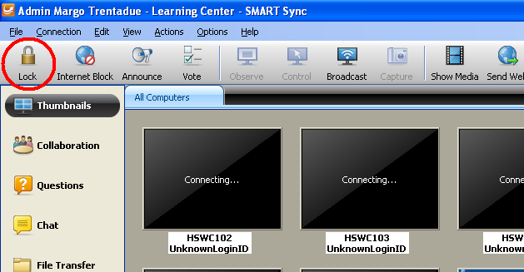
Broadcasting Your Desktop
You can broadcast your desktop to the entire class or select students in either Full Screen or Window mode. In Full Screen mode, your broadcast fills the students’ screens, and they can’t view or use other applications during the broadcast. In Window mode, your desktop appears in a window on the students’ desktops and they can switch between this window and other applications.
To broadcast your desktop:
- Click Thumbnails.
The Thumbnails view appears.
- Click All Computers or All Students to broadcast to all students
OR
Select students’ thumbnails to broadcast to only those students.
- Click Broadcast.
A message appears, asking if you want to broadcast your desktop.
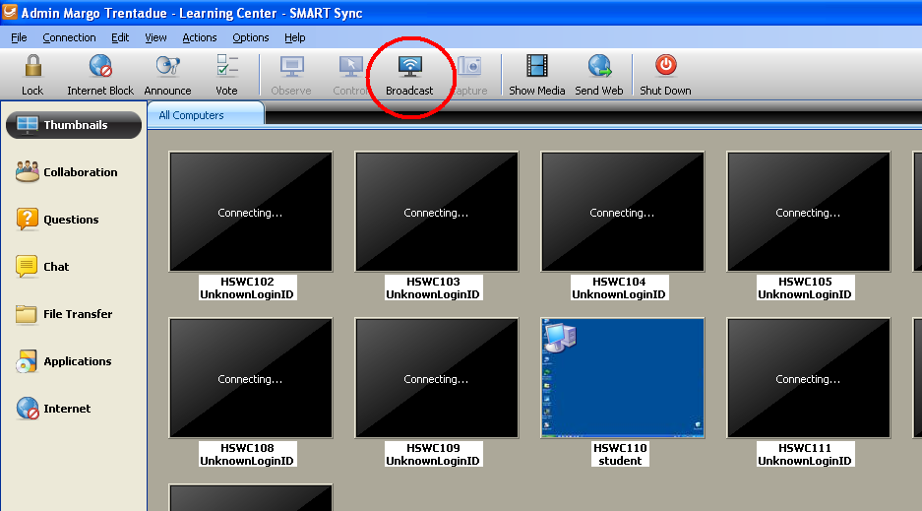
- Click Yes.
Your desktop appears on the selected students’ computers. The My Desktop toolbar appears on your computer.
- Select Menu > Stop Broadcasting when you’re finished.
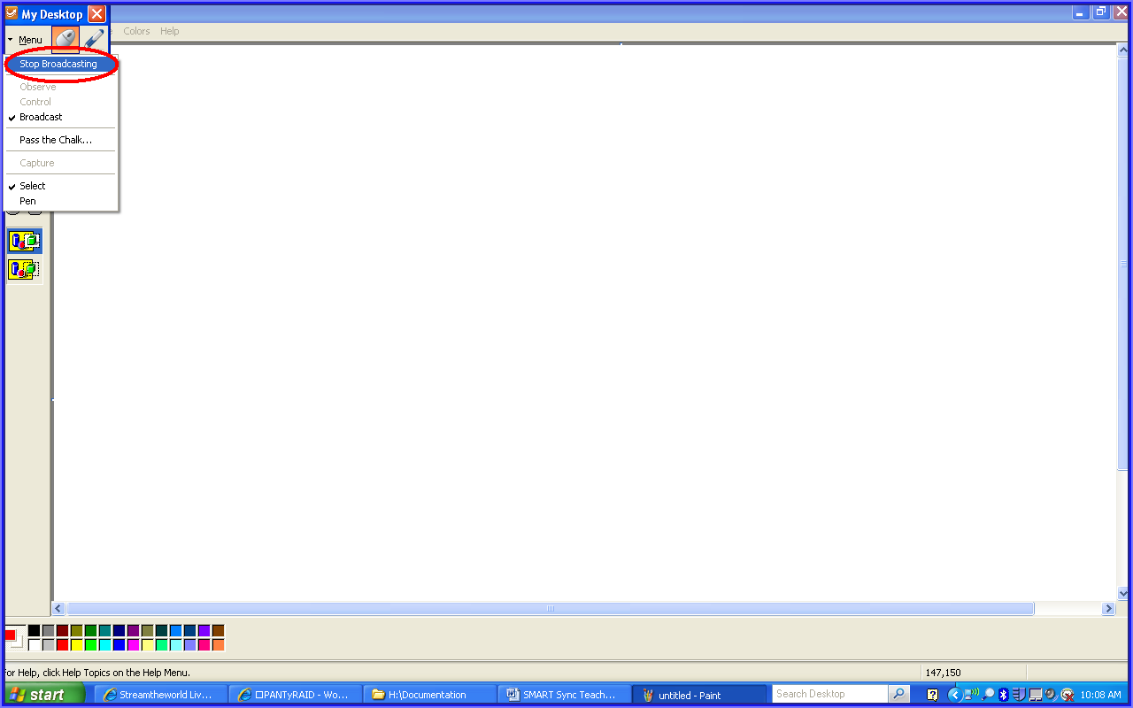

Broadcasting a Student’s Desktop
You can broadcast a student’s desktop to the entire class or to a group. You can take control of the student’s mouse and keyboard, share control with the student or let the student keep control.
You can broadcast in either Full Screen or Window mode. In Full Screen mode, your broadcast fills the students’ screens, and they can’t view or use other applications during the broadcast. In Window mode, your desktop appears in a window on the students’ desktops and they can switch between this window and other applications.
To broadcast a student’s desktop:
- Click Thumbnails.
The Thumbnail view appears.
- Select the thumbnail of the student whose desktop you wish to broadcast.
- Click Broadcast.
A message appears, asking to broadcast the selected desktop.
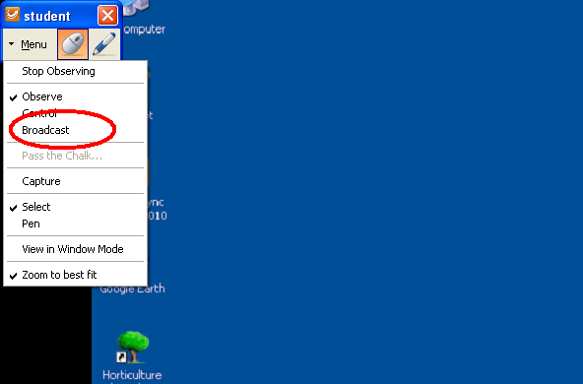
- Click Yes.
The student’s desktop appears on your computer and the other student’s computers.
- Click Stop when you’re finished.

Shutting Down, Logging Off and Restarting Students’ Computers
Students may leave their computers in a variety of states at the end of the day. Some students may log off and shut down, and others may leave their applications running. You can remotely shut down, log off or restart the computers of your entire class or selected student(s).
Caution:
Shutting down, logging off or restarting a computer can result in the loss of unsaved data. Please advise students to save their work before you perform any of these actions.
To shut down, log off or restart students’ computers:
- Click Thumbnails.
The Thumbnails view appears.
- Click All Computers or All Students to shut down, log off or restart all students’ computers
OR
Select a student’s thumbnail to shut down, log off or restart that student’s computer.
- Click Shut Down.
The Shut Down Students dialog box appears.
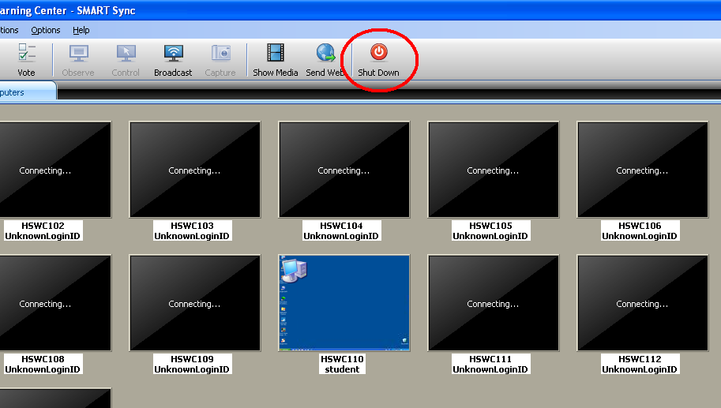
- Select Shut down from the drop-down list
OR
Select Log off from the drop-down list
OR
Select Restart from the drop-down list.

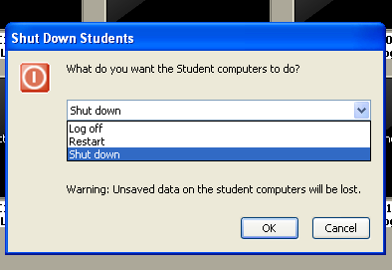
- Click OK.

